### Task 1 (Ip Address of your Computer)

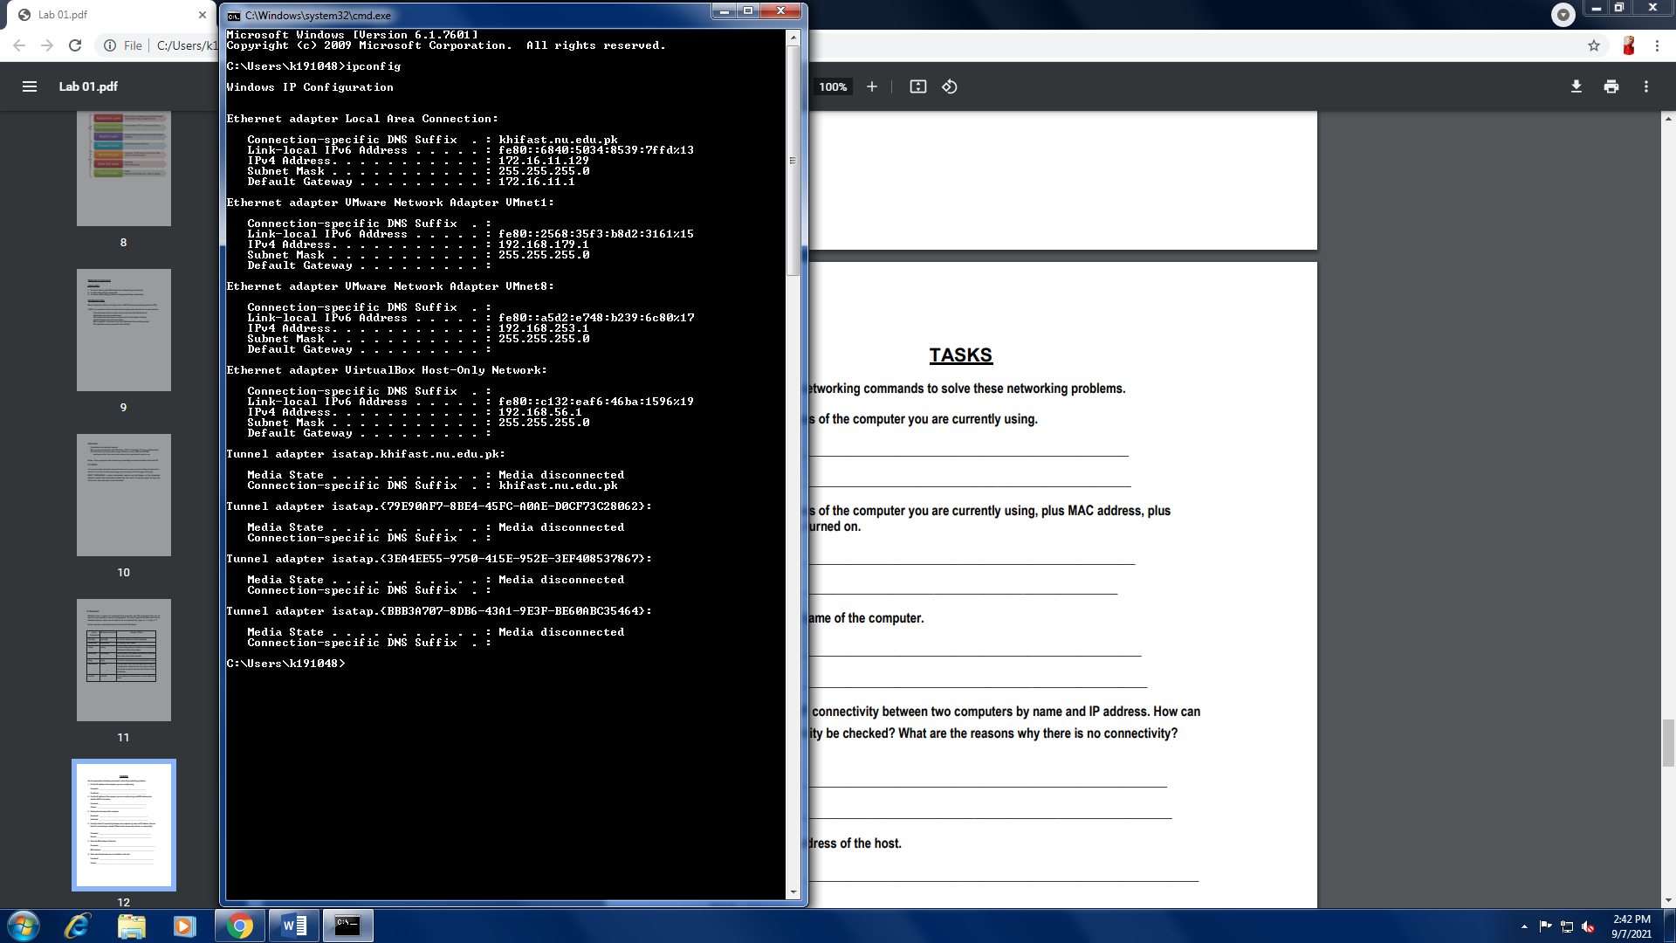

### Task 2 (Mac address and dhcp status)

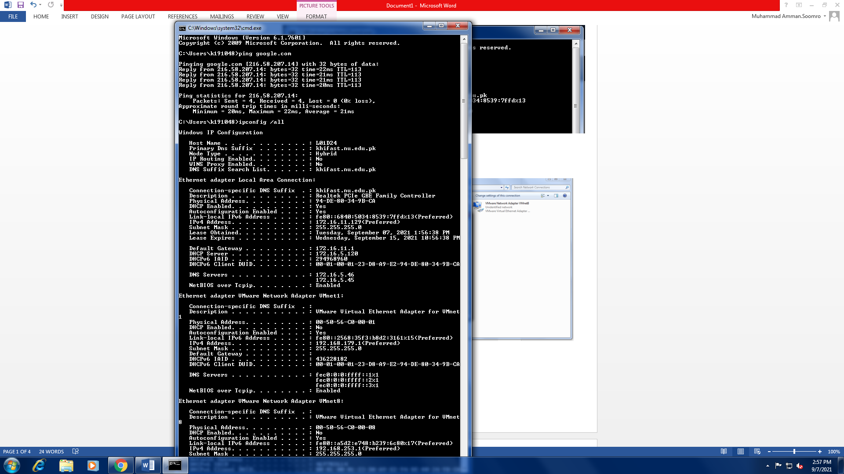

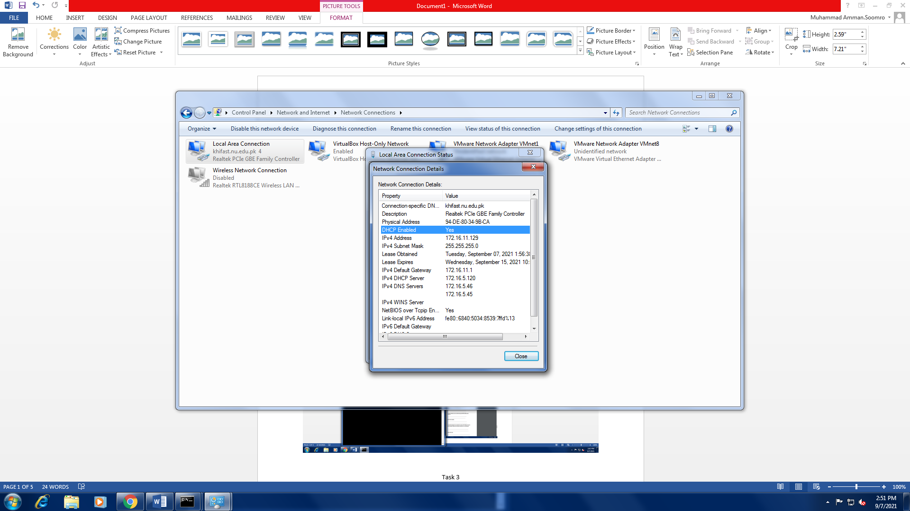

### Task 3 (Hostname of your computer)

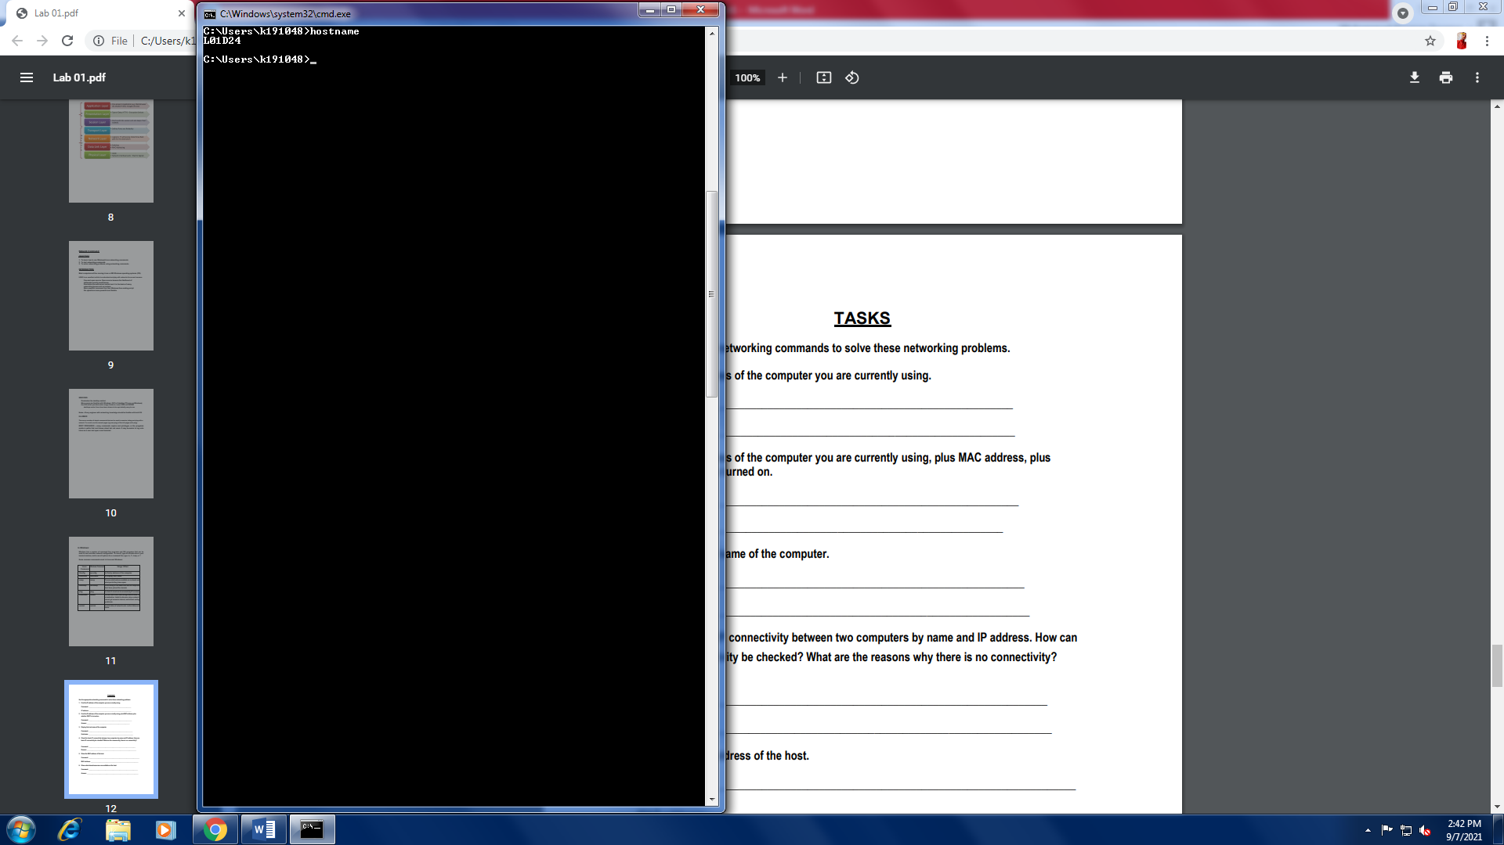

### Task 4 (Ip connectivity between two computers)

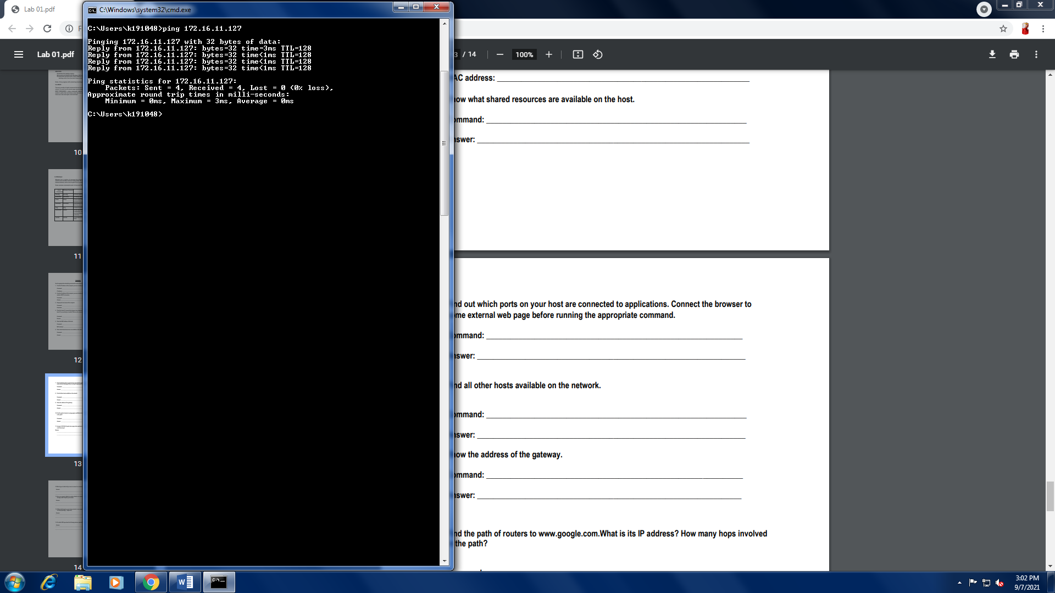

### Task 5 (Mac Address of host)

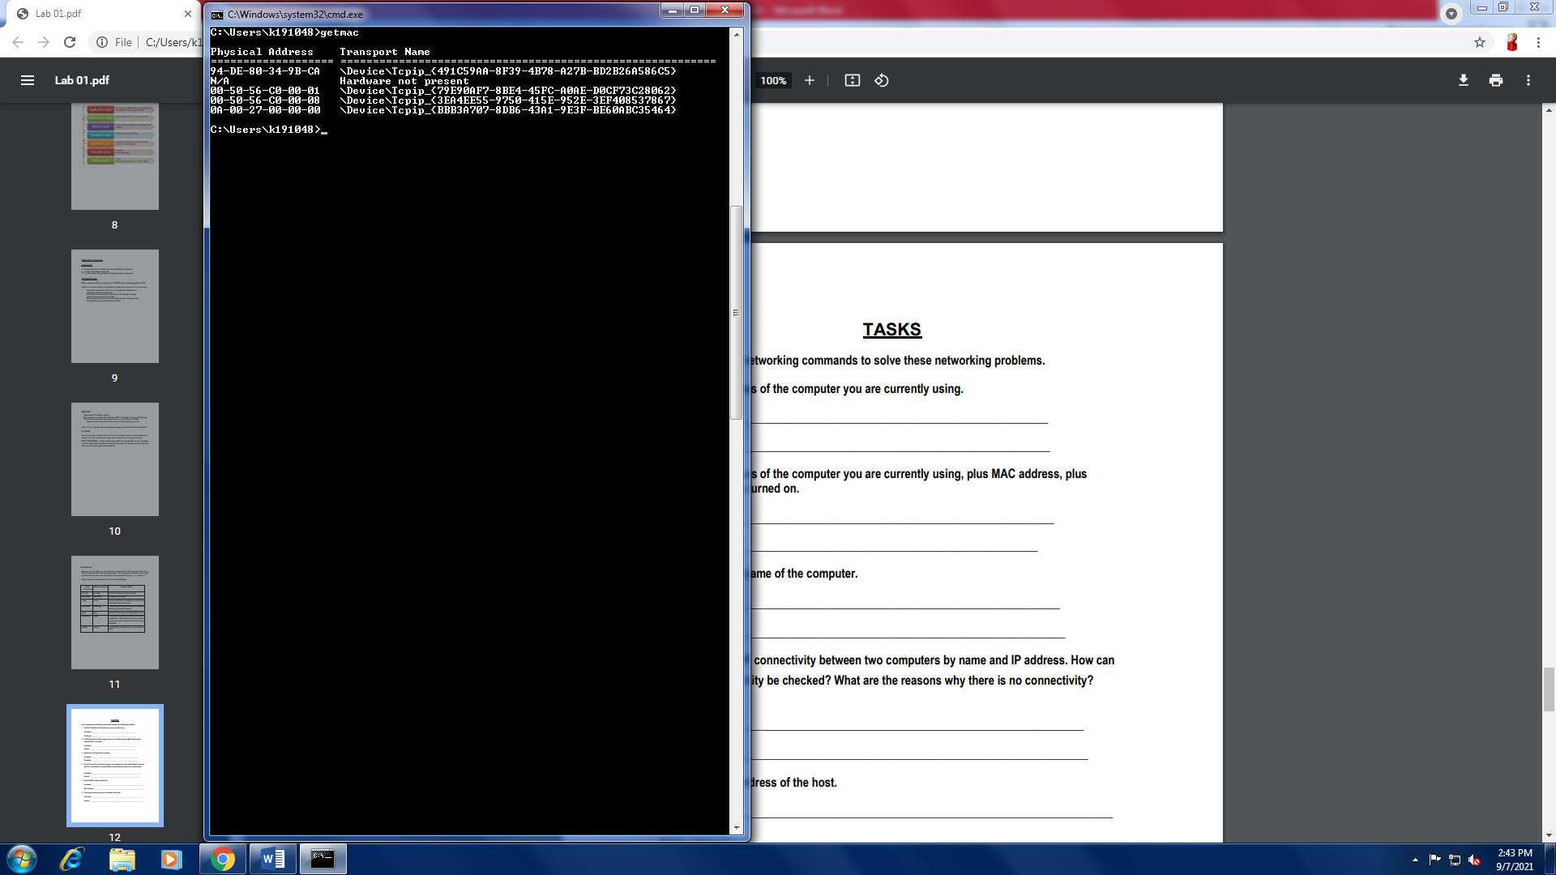

### Task 6 (Share resources)

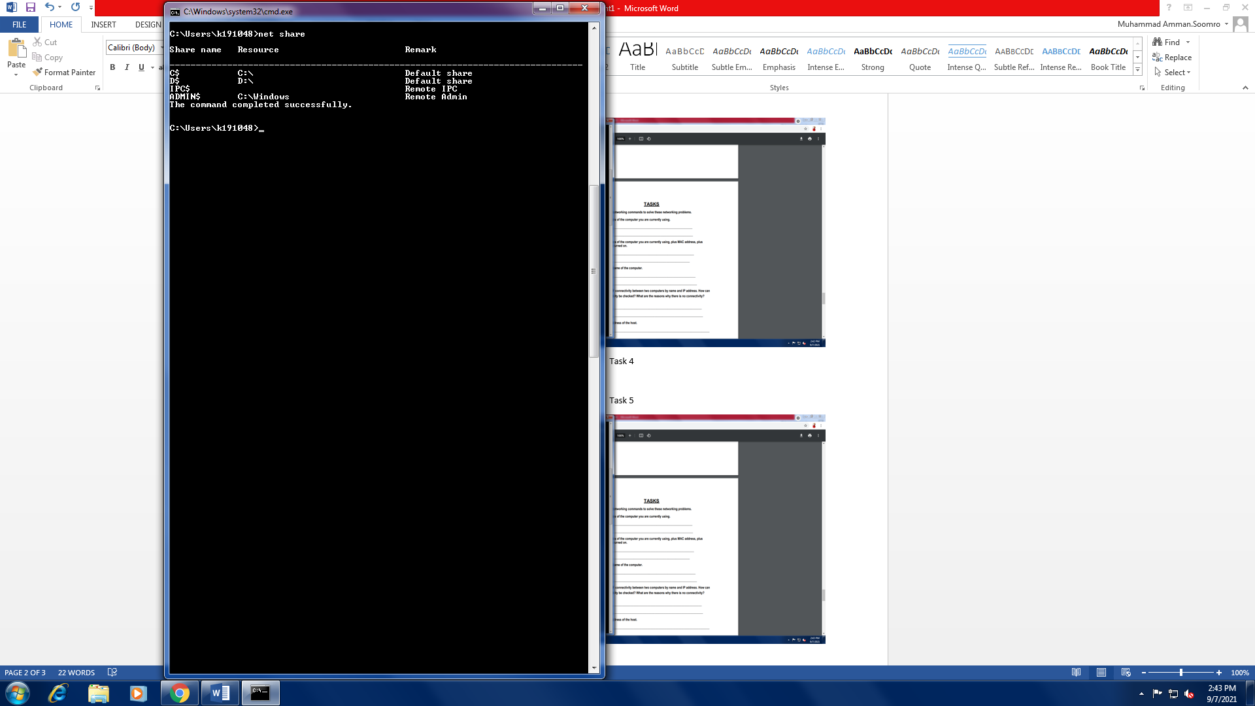

### Task 7 (Ports on host connected to applications)

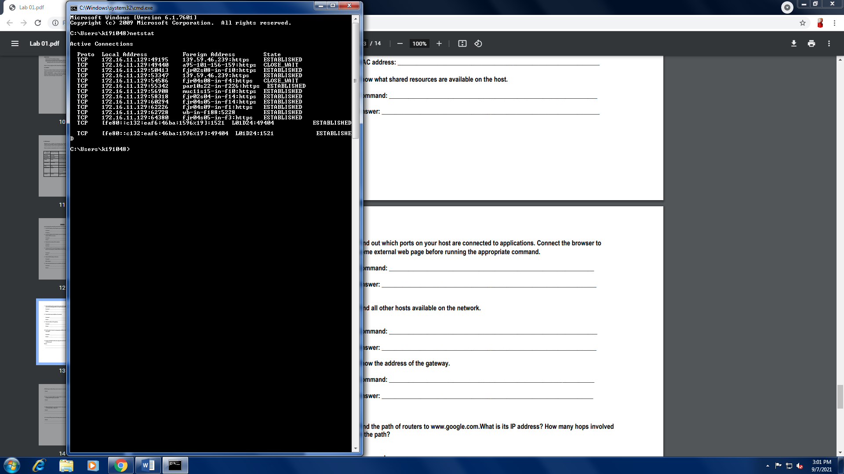

### Task 8 (all other hosts available on network)

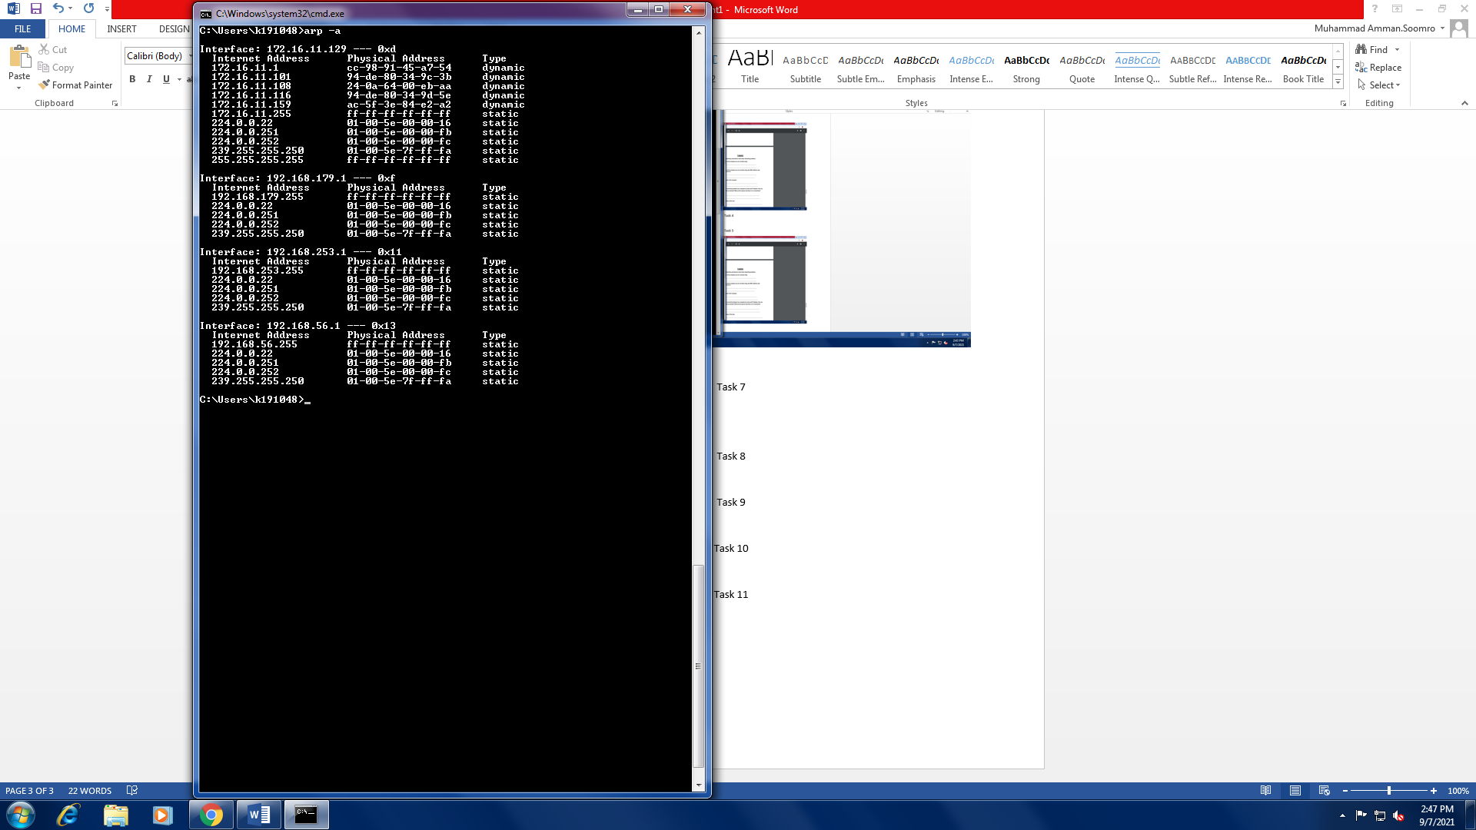

### Task 9 (Default Gateway)

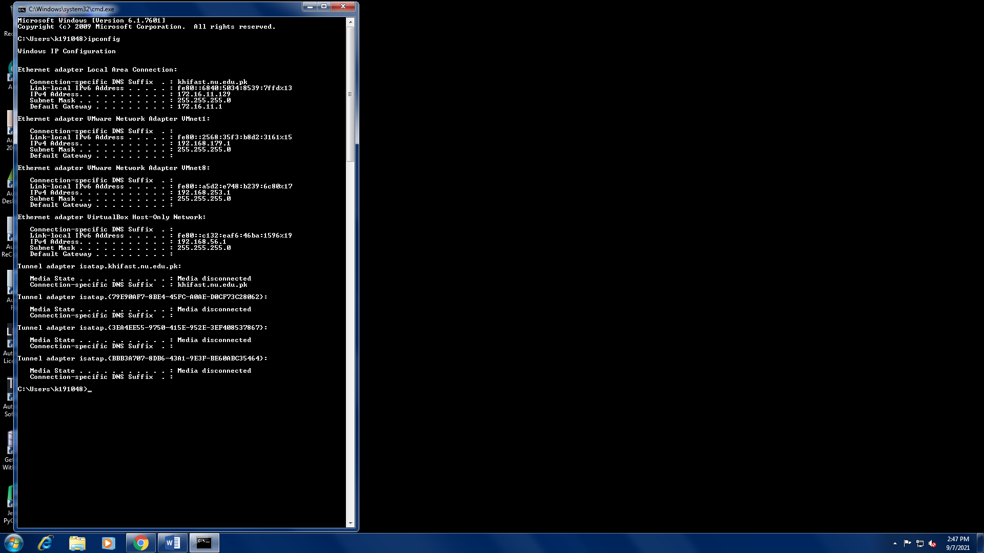

### Task 10 (Path of routers to google.com)

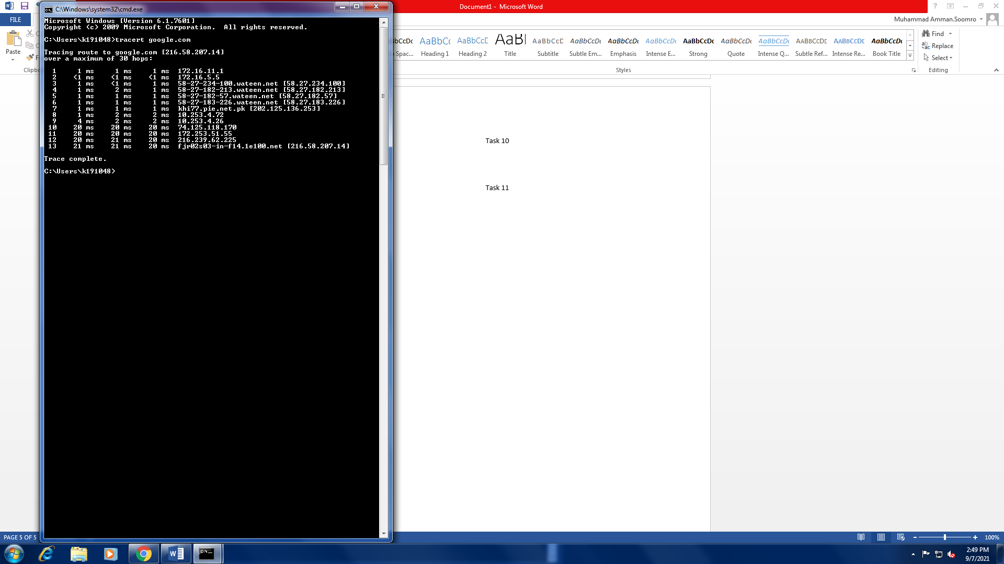

### Task 11 (Blue Machine fails)

Hostname could be Wrong.

### Task 12 (Normal home installation)

Straight-Through ethernet cables with RJ-45 connectors.

### Task 13 (switch to another swtich using straight through cable)

No, Straight-Through cables are used to connect different devices together.

For Example:

1. Router to Hub
2. Computer to Switch

Cross-Over cables can be used to make connection between the devices mentioned in the question.

### Task 14 (Home network setup)

Star-Topology is installed in my home, since it is easy and cheap to setup, and It’s got several advantages such as,

1. It is easy to troubleshoot and maintain.
2. More devices can be added very easily.
3. It uses Ethernet cables that are also very cheap and easy to obtain.
4. It’s performance is fast with low traffic.

### Task 15 (Osi layers)

* Hub 🡪 Physical Layer
* Switch 🡪 Data Link Layer
* Router 🡪 Network Layer